

**User Story Title**

**C09248 - IMPLEMENTATION OF AIRTEL CASH IN ENQUIRY**

**SOLUTION DESIGN DOCUMENT**

**03-Dec-2024**

**Version** **1.0**

This document contains confidential information and is supplied under the terms of an Agreement with the KCB Bank Kenya Ltd., which provides that it is intended only for the individuals or entity named here in. Disclosure, copying or distribution of the contents of this document is strictly prohibited

# Proprietary Notice

This document contains information specific and confidential to KCB Bank Kenya Ltd. Reading this document is an undertaking to observe the confidentiality and copyright of the KCB Bank Kenya Ltd information and to undertake that the information contained herein will not be reproduced in whole or part, discussed, or distributed under any circumstances without the prior written permission of KCB Bank Kenya Ltd.

# Approvals and Revision History

## Document Approval

| **Version** | **Name** | **Role/Department** | **Signature** | **Date** |
| --- | --- | --- | --- | --- |
| 1.0 | Michael Chesseto | Data Architect, GEA | A close up of a signature  Description generated with high confidence | 03/12/2024 |
| 1.0 |  |  |  |  |

## Revision History

| **Date** | **Version** | **Description of Change** | **Change done by** | **Department/Unit** |
| --- | --- | --- | --- | --- |
| 03-Dec-2024 | 1.0 | Cash withdrawal for Cards on Agency | Michael Chesseto | GEA |
|  |  |  |  |  |
|  |  |  |  |  |
|  |  |  |  |  |
|  |  |  |  |  |

## Reference Documents

| **ID** | **Document Name** | **Description** | **Document** |
| --- | --- | --- | --- |
| 1 | Airtel Cash in Enquiry | BRD Documentation |  |
| 2 | Airtel Money API Specification | API Specifications |  |

Table of Contents

Proprietary Notice 2

Approvals and Revision History 2

Document Approval 2

Revision History 2

Reference Documents 2

1. Pre-conditions 4

2. Problem Statement 4

3. Post-conditions 4

4. Acceptance Criteria 5

5. Architecture 5

6. Service Sequence Flows 8

7. Assumptions 9

8. Risks 9

9. Out of scope 9

10. MIS / Reporting 9

11. Security 9

Appendixes 10

# Problem Statement

In the current setup for Airtel cash-in transactions at KCB Agent outlets, the successful completion of a deposit is contingent upon receiving a callback notification from Airtel. This callback is required to verify the transaction and allow KCB to process the corresponding credit (CR) or debit (DR) entries. However, there are instances where Airtel fails to send this callback. Consequently, while the deposit reflects as successful on Airtel’s side, it remains unconfirmed on KCB’s systems, resulting in Reconciliation challenges due to lack of visibility by the partner.

The absence of a reliable callback from Airtel confirming deposits at KCB agent outlets has resulted in reconciliation issues and inaccurate transaction records. This gap poses operational challenges for KCB, as it lacks visibility in completed transactions that are not reflected in its system, causing difficulties in tracking and verifying deposits.

As a solution, developing an Airtel Enquiry API for cash-in transactions would allow KCB to check the transaction status on Airtel’s system, ensuring accurate updates on KCB's end and facilitating smoother reconciliations.

# Post- conditions

Post-conditions for implementation of Airtel Cash in Enquiry Include:

1. Integrate the Airtel Enquiry API in OCP to confirm status of the transaction in cases where the API call back fails.
2. Cash is deposited to customer’s Airtel Mobile number

# Acceptance Criteria

Acceptance Criteria for implementation of Airtel Cash in Enquiry Include:

1. Integrate the Airtel Enquiry API in OCP to confirm status of the transaction in cases where the API call back fails.
2. Cash is deposited to customer’s Airtel Mobile number

# Architecture

* 1. High Level Architecture Design of Airtel Cash In Service

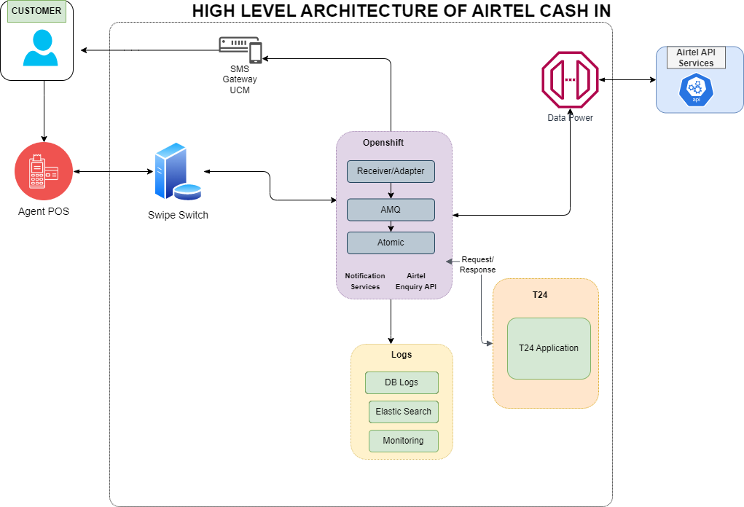

**Architecture Components**

| **#** | **COMPONENT NAME** | **COMPONENT DESCRIPTION** |
| --- | --- | --- |
| 1 | T24 | Core banking system |
| 2 | POS | Point of Sale used by agents to initiate the requisite transactions |
| 3 | Swipe Switch | POS terminals backend used to route requests from POS to Agency Bridge |
| 4 | OCP Services | Is a platform that helps organizations develop, deliver, deploy and manage containerized applications |

* 1. **Solution Overview**

The Solution entails developing Airtel Enquiry API to verify the status of cash-in transactions conducted by agents. This API will allow KCB to query Airtel’s API End point to confirm transaction completion in cases where the API call back fails.

# Service Sequence Flows

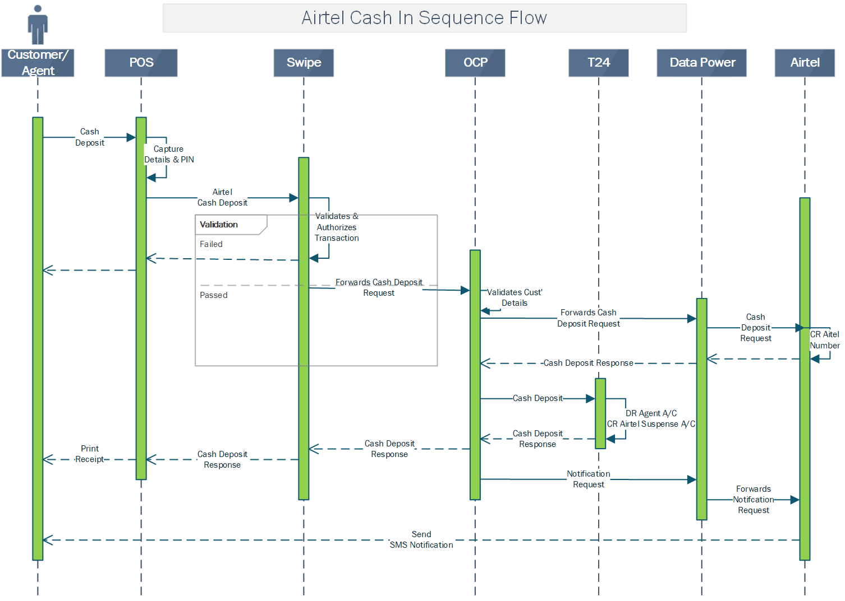

**Description of the Transactional Flow:**

1. The customer approaches a KCB agent for Airtel Money cash deposit, and the agent inputs the customer’s phone number and deposit amount on the POS terminal.
2. The transaction gets forwarded to Swipe Switch
3. Swipe Switch validates the transaction and forwards to OCP
4. OCP Validates customer details and forwards the transaction to Airtel API Services through Data Power
5. Airtel API Services CR Customer Mobile Number and provides a response to OCP through Data Power.
6. In the event API Call back fails, Airtel Enquiry service will be invoked to confirm status of the transaction.
7. Upon receiving a successful call, OCP Service will forward the cash deposit request to T24
8. T24 will execute financial entries to:
   1. DR agent Account
   2. CR Airtel Suspense account
9. A notification service will be invoked to send transition notification to Customer through SMS gateway

## Interface

### Sequence Flow

NA

### Interface Details

NA

### Interface Design

N/A

### Request Schemer

**POST Endpoint:** <base_url> /api/v1/queryTransaction/{transactionId}

**Authorization Type:** Basic <base64(username:password)>

**Response Payload (Sample)**{

"data": {

"transaction": {

"airtel_money_id": "product-partner-ABCD1234",

"id": "ABCD1234",

"status": "TS"

}

},

"status": {

"code": "200",

"message": "Success",

"result_code": "DP01000001001",

"success": false

}

}

### Response Schema

200 Response

{

"data": {

"transaction": {

"id": "ASDJBEJB4KRN5",

"status": "SUCCESS"

}

},

"status": {

"code": "200",

"message": "SUCCESS",

"result_code": "ESB000010",

"response_code": "DP00800001006",

"success": true

}

}

400 Response

{

"data": {

"transaction": {

"id": "ASDJBEJB4KRN5",

"status": "Failed"

}

},

"status": {

"code": "400",

"message": "Failed",

"result_code": "ESB0000101",

"response_code": "DP008000010890",

"success": false

}

}

### Airtel Cash-In Error Codes

|  |  |  |
| --- | --- | --- |
| Error Code | Expected Error reason | Description |
| DP01000001000 | Unknown | Your payment could not be completed, Please try again |
| DP01000001001 | Success | Transaction is successful |
| DP01000001002 | Incorrect Pin | Incorrect Pin has been entered |
| DP01000001003 | Exceeds withdrawal amount limit(s) / Withdrawal amount limit exceeded | The User has exceeded their wallet allowed transaction limit |
| DP01000001004 | Invalid Amount | The amount User is trying to transfer is less than the minimum amount allowed |
| DP01000001005 | Failed | Failed |
| DP01000001006 | In process | Transaction in pending state. Please check after sometime |
| DP01000001007 | Insufficient Funds | User wallet does not have enough money to cover the payable amount |
| DP01000001008 | User Not Allowed | User is not allowed as a payer |
| DP01000001009 | Initiatee Invalid | Initiatee is invalid |
| DP01000001010 | Not Permitted | User not allowed as payer |
| DP01000001011 | Do Not Honour | Transaction is already completed |
| DP01000001012 | Invalid Mobile Number | Mobile number entered is incorrect or not registered |

### HTTPS Status Codes

|  |  |
| --- | --- |
| **CODE** | **Description** |
| 200 | Success |
| 400 | Bad Request |
| 401 | Unauthorized |
| 500 | Internal Server Error |

# Assumptions

Sufficient technical resources, including skilled personnel and necessary tools, will be available to implement, test, and monitor the changes.

# Risks

N/A

# In Scope

* OCP
* Swipe Switch

# Out of scope

* Agency Bridge

# MIS / Reporting

N/A

# Security

Minimum security Baseline Report



# Appendixes

| **Acronym or Term** | **Definition** |
| --- | --- |
| T24 | Core banking system. |
| POS | Point of Sale Terminal |
| POS | Point of Sale |
| Swipe | POS terminals backend |
| DB | Database |